- Online Retail Sales Database Design
Objective: Design a normalized SQL schema for an e-commerce platform.
Tools: MySQL / PostgreSQL, dbdiagram.io
1.Identify key entities: Products, Customers, Orders, Payments.
1. Products
Represents the items available for sale.
Key attributes:
- product_id (Primary Key)
- product_name
- description
- price
- stock_quantity
- category
- created_at
- updated_at
2. Customers
Represents users who purchase products.
Key attributes:
- customer_id (Primary Key)
- first_name
- last_name
- email
- phone_number
- address
- created_at
3. Orders
Represents a transaction where a customer purchases one or more products.
Key attributes:
- order_id (Primary Key)
- customer_id (Foreign Key → Customers)
- order_date
- shipping_address
- status (e.g., Pending, Shipped, Delivered)
- total_amount
Related Table: Order_Items (for multiple products per order)
- order_item_id (Primary Key)
- order_id (Foreign Key → Orders)
- product_id (Foreign Key → Products)
- quantity
- price_at_order_time
4. Payments
Represents payment information for an order.
Key attributes:
- payment_id (Primary Key)
- order_id (Foreign Key → Orders)
- payment_date
- amount_paid
- payment_method (e.g., Credit Card, UPI, PayPal)
- payment_status (e.g., Paid, Failed, Refunded)

2.Design ER diagram
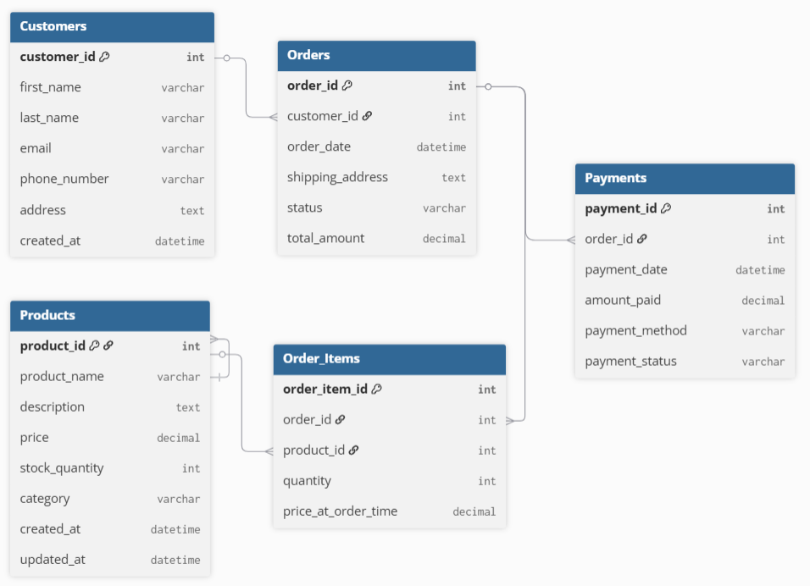

To normalize your database schema to Third Normal Form (3NF), we'll follow three steps:
Step 1: First Normal Form (1NF)
Goal: Eliminate repeating groups and ensure atomic (indivisible) values.
- All attributes should have atomic values.
Our schema already satisfies this.
Step 2: Second Normal Form (2NF)
Goal: Remove partial dependencies
(A non-key column should depend on the whole primary key—not part of it.)
- In Order_Items, the primary key is order_item_id (surrogate key), and each column depends fully on it.
Already in 2NF.
Step 3: Third Normal Form (3NF)
Goal: Remove transitive dependencies
(Non-key attributes should only depend on the primary key, not on other non-key attributes.)
Now we review each table:
Customers
customer_id (PK)
first_name, last_name, email, phone_number, address, created_at
- No transitive dependency.
✅ 3NF
Products
product_id (PK)
product_name, description, price, stock_quantity, category, created_at, updated_at
- If category has detailed information, it can be moved to a separate Categories table:
Normalized:
Table: Categories
- category_id (PK)
- category_name
Table: Products
- product_id (PK)
- ...other fields...
- category_id (FK → Categories)
Optional normalization depending on category complexity.
Orders
order_id (PK)
→ customer_id, order_date, shipping_address, status, total_amount
- shipping_address could be normalized into a separate table if reused.
Normalization of shipping_address is optional unless used across multiple orders.
Order_Items
order_item_id (PK)
→ order_id, product_id, quantity, price_at_order_time
Already in 3NF.
Payments
text
CopyEdit
payment_id (PK)
→ order_id, payment_date, amount_paid, payment_method, payment_status
Already in 3NF.
Final 3NF Schema Summary:
- Customers
- Products
- Orders
- Order_Items
- Payments
- (Optional): Categories, Shipping_Addresses

Final 3NF Schema (Entities & Relationships):

Customers
- customer_id (PK)
- first_name
- last_name
- email
- phone_number
- created_at

Addresses (optional normalization)
- address_id (PK)
- customer_id (FK → Customers.customer_id)
- street
- city
- state
- zip_code
- country
Used if customers may have multiple addresses (billing/shipping)

Categories (optional normalization)
- category_id (PK)
- category_name

Products
- plaintext
- CopyEdit
- product_id (PK)
- product_name
- description
- price
- stock_quantity
- category_id (FK → Categories.category_id)
- created_at
- updated_at

Orders
- order_id (PK)
- customer_id (FK → Customers.customer_id)
- order_date
- shipping_address_id (FK → Addresses.address_id)
- status
- total_amount

Order_Items
- order_item_id (PK)
- order_id (FK → Orders.order_id)
- product_id (FK → Products.product_id)
- quantity
- price_at_order_time

Payments
- payment_id (PK)
- order_id (FK → Orders.order_id)
- payment_date
- amount_paid
- payment_method
- payment_status

Highlights of 3NF Changes:
Table | Change
Products | Moved category to a separate Categories table
Orders | Moved shipping_address to a normalized table
Customers | Address no longer directly inside the Customers table
All tables | No partial or transitive dependencies

4. Write DDL scripts to create tables with constraints.
DDL (Data Definition Language) scripts to create the normalized tables with appropriate primary keys, foreign keys, and constraints for the schema in 3NF.
1. Postal_Codes Table
CREATE TABLE Postal_Codes (
postal_code VARCHAR(10) PRIMARY KEY,
city VARCHAR(100) NOT NULL,
state VARCHAR(100) NOT NULL,
country VARCHAR(100) NOT NULL
);
2. Customers Table
CREATE TABLE Customers (
customer_id INT PRIMARY KEY AUTO_INCREMENT,
first_name VARCHAR(50) NOT NULL,
last_name VARCHAR(50) NOT NULL,
email VARCHAR(100) UNIQUE NOT NULL,
phone VARCHAR(15),
address VARCHAR(255),
postal_code VARCHAR(10),
FOREIGN KEY (postal_code) REFERENCES Postal_Codes(postal_code)
);
3. Products Table
CREATE TABLE Products (
product_id INT PRIMARY KEY AUTO_INCREMENT,
product_name VARCHAR(100) NOT NULL,
category VARCHAR(50),
description TEXT,
price DECIMAL(10, 2) NOT NULL CHECK (price >= 0),
stock_quantity INT DEFAULT 0 CHECK (stock_quantity >= 0)
);

4. Orders Table
CREATE TABLE Orders (
order_id INT PRIMARY KEY AUTO_INCREMENT,
customer_id INT NOT NULL,
order_date DATE NOT NULL,
order_status VARCHAR(50) DEFAULT 'Pending',
shipping_address VARCHAR(255),
FOREIGN KEY (customer_id) REFERENCES Customers(customer_id)
);

5. Order_Items Table
CREATE TABLE Order_Items (
order_id INT,
product_id INT,
quantity INT NOT NULL CHECK (quantity > 0),
unit_price DECIMAL(10, 2) NOT NULL CHECK (unit_price >= 0),
PRIMARY KEY (order_id, product_id),
FOREIGN KEY (order_id) REFERENCES Orders(order_id),
FOREIGN KEY (product_id) REFERENCES Products(product_id)
);
6. Payments Table
CREATE TABLE Payments (
payment_id INT PRIMARY KEY AUTO_INCREMENT,
order_id INT NOT NULL,
payment_date DATE NOT NULL,
payment_method VARCHAR(50) NOT NULL,
amount DECIMAL(10, 2) NOT NULL CHECK (amount >= 0),
FOREIGN KEY (order_id) REFERENCES Orders(order_id)
);

Notes:
- AUTO_INCREMENT is used for primary keys where applicable (you can change it to SERIAL or IDENTITY depending on the RDBMS like MySQL/PostgreSQL/SQL Server).
- Constraints like CHECK, UNIQUE, and FOREIGN KEY ensure data validity.
- You can add ON DELETE CASCADE or ON UPDATE CASCADE to foreign keys if needed.

5.Populate tables with sample data.
Postal_Codes
INSERT INTO Postal_Codes (postal_code, city, state, country)
VALUES
('560001', 'Bangalore', 'Karnataka', 'India'),
('10001', 'New York', 'NY', 'USA');
Customers
INSERT INTO Customers (first_name, last_name, email, phone, address, postal_code)
VALUES
('Ravi', 'Kumar', 'ravi.k@example.com', '9876543210', '123 MG Road', '560001'),
('Alice', 'Smith', 'alice.smith@example.com', '1234567890', '456 Park Ave', '10001');

Products
INSERT INTO Products (product_name, category, description, price, stock_quantity)
VALUES
('Laptop', 'Electronics', 'High performance laptop', 75000.00, 10),
('Headphones', 'Accessories', 'Noise-cancelling headphones', 3000.00, 50);

Orders
INSERT INTO Orders (customer_id, order_date, order_status, shipping_address)
VALUES
(1, '2025-07-20', 'Shipped', '123 MG Road, Bangalore'),
(2, '2025-07-21', 'Processing', '456 Park Ave, New York');

Order_Items
INSERT INTO Order_Items (order_id, product_id, quantity, unit_price)
VALUES
(1, 1, 1, 75000.00),
(1, 2, 2, 3000.00),
(2, 2, 1, 3000.00);

Payments
INSERT INTO Payments (order_id, payment_date, payment_method, amount)
VALUES
(1, '2025-07-22', 'Credit Card', 81000.00),
(2, '2025-07-22', 'UPI', 3000.00);

6.Write JOIN queries and views for sales reports.
1) Total Sales per Product
SELECT
p.product_id,
p.product_name,
SUM(oi.quantity) AS total_quantity_sold,
SUM(oi.unit_price * oi.quantity) AS total_sales
FROM Order_Items oi
JOIN Products p ON oi.product_id = p.product_id
GROUP BY p.product_id, p.product_name
ORDER BY total_sales DESC;

2. Customer Purchase Summary
SELECT
c.customer_id,
CONCAT(c.first_name, ' ', c.last_name) AS customer_name,
COUNT(DISTINCT o.order_id) AS total_orders,
SUM(oi.unit_price * oi.quantity) AS total_spent
FROM Customers c
JOIN Orders o ON c.customer_id = o.customer_id
JOIN Order_Items oi ON o.order_id = oi.order_id
GROUP BY c.customer_id, customer_name
ORDER BY total_spent DESC;

3. Daily Sales Report
SELECT
o.order_date,
COUNT(DISTINCT o.order_id) AS orders_placed,
SUM(oi.unit_price * oi.quantity) AS revenue
FROM Orders o
JOIN Order_Items oi ON o.order_id = oi.order_id
GROUP BY o.order_date
ORDER BY o.order_date;

4. Payments Report (by Method)
SELECT
payment_method,
COUNT(payment_id) AS payment_count,
SUM(amount) AS total_amount
FROM Payments
GROUP BY payment_method
ORDER BY total_amount DESC;

5. View: Sales Summary per Order
CREATE VIEW Sales_Summary AS
SELECT
o.order_id,
o.order_date,
CONCAT(c.first_name, ' ', c.last_name) AS customer_name,
SUM(oi.unit_price * oi.quantity) AS order_total,
p.payment_method,
p.payment_date
FROM Orders o
JOIN Customers c ON o.customer_id = c.customer_id
JOIN Order_Items oi ON o.order_id = oi.order_id
LEFT JOIN Payments p ON o.order_id = p.order_id
GROUP BY o.order_id, o.order_date, customer_name, p.payment_method, p.payment_date;

You can now run:
SELECT * FROM Sales_Summary WHERE order_total > 5000;

